**Lab 3: Table and Forms**

1. Complete the following table:

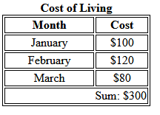

Take a screenshot of your source code and paste here.

|  |
| --- |
| <!DOCTYPE html>  <html lang="en">  <head>  <meta charset="UTF-8">  <meta name="viewport" content="width=device-width, initial-scale=1.0">  <title>Lab 3</title>  </head>  <body>    <table border="1px" cellpadding="4px" align="center" width="250px">  <caption><b>Cost of Living</b></caption>  <tr align="center">  <td>Month</td>  <td>Cost</td>  </tr>  <tr align="center">  <td>January</td>  <td>$100</td>  </tr>  <tr align="center">  <td>February</td>  <td>$120</td>  </tr>  <tr align="center">  <td>March</td>  <td>$80</td>  </tr>  <tr align="right">  <td colspan="2">Sum: $300</td>  </tr>  </table>  </body>  </html> |

1. Complete the following forms:

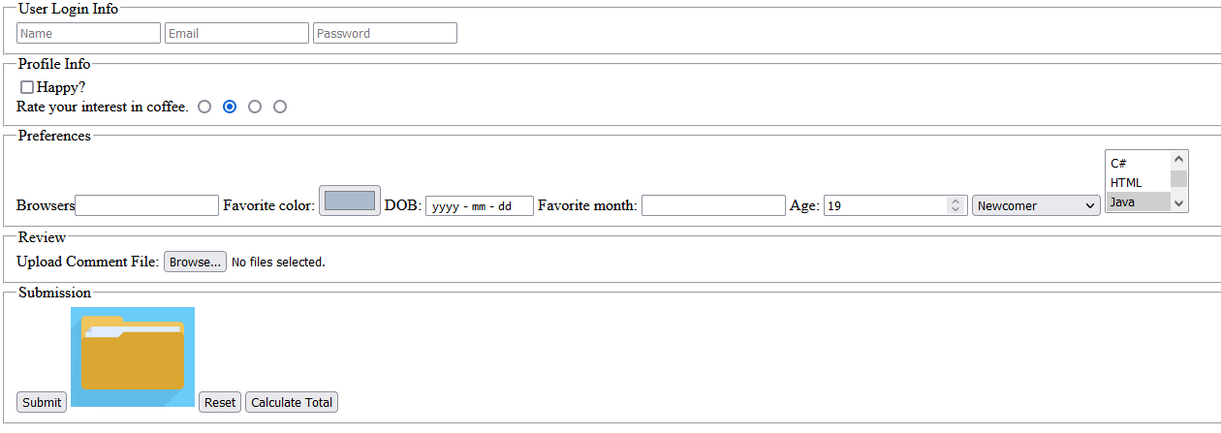

Paste your web page source code here.

|  |
| --- |
| <!DOCTYPE html>  <html lang="en">  <head>  <meta charset="UTF-8">  <meta name="viewport" content="width=device-width, initial-scale=1.0">  <title>Document</title>  </head>  <body>  <form method="post">    <fieldset>  <legend>User Login Info</legend>  <div id="UserLoginInfo">  <input type="text" placeholder="Name" name="Name of the User">  <input type="text" placeholder="Email" name="Email of the User">  <input type="password" placeholder="Password" name="Password entered">    </div>    </fieldset>  <fieldset>  <legend>Profile Info</legend>    <div>  <input type="checkbox" name="Happy or not" id="profileInfoHappy"><label for="profileInfoHappy">Happy?</label> <br>  </div>    <div>    <label for="interestRate">Rate your interest in coffee.</label>  <input type="radio" name="rating" id="interestRate" value="1/4"><input type="radio" value="2/4" name="rating" id=""><input value="3/4" type="radio" name="rating" id=""><input type="radio" name="rating" id="" value="4/4">    </div>    </fieldset>  <fieldset>  <legend>Preferences</legend>    <div>  <label for="browserBox">Browsers</label> <input name="Favorite Browsers" id="browserBox" type="text">  <label for="favoriteColor">Favorite:</label> <input name = "Favorite color" id = "favoriteColor" type="color">  <label for="dateOfBirth">DOB:</label> <input id="dateOfBirth" type="date" name="Date of birth">  <label for="favMonth">Favorite month:</label> <input id="favMonth" type="text" name="Favorite month">  <label for="age">Age:</label> <input id="age" type="number" name="Age">  <select name="Status" name="Satus of immigration">  <option value="Newcomer">Newcomer</option>  <option value="Citizen">Citizen</option>  <option value="PR">PR</option>  </select>  <select name="Status" multiple size="3" name="Language selection">  <option value="C#">C#</option>  <option value="HTML">HTML</option>  <option value="Java">Java</option>  </select>  </div>    </fieldset>  <fieldset>  <legend>Review</legend>    <div>  <label for="chooseFile">Upload Comment File:</label> <input id="chooseFile" type="file">  </div>    </fieldset>  <fieldset>  <legend>Submission</legend>    <div>  <input type="submit" name="Submit" value="Submit">  <img src="folder-icon.jpg" alt="folder logo" width="5%">  <input type="reset" name="reset" value="Reset">  <input type="button" name="Calculate" value="Calculate Total">    </div>    </fieldset>  </form>  </body>  </html> |